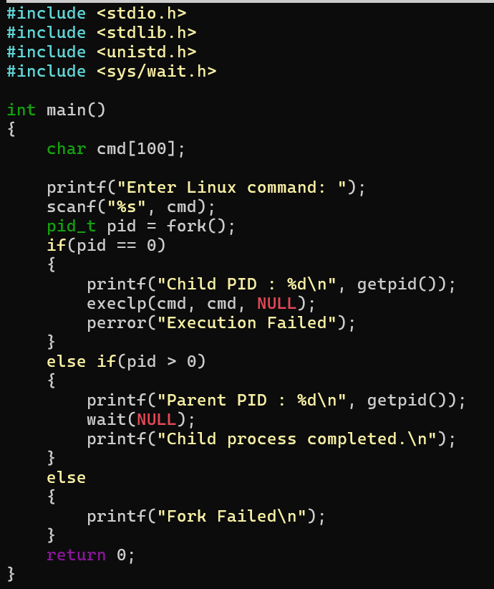

Try uname, lscpu, lsblk, ps, top commands after this program
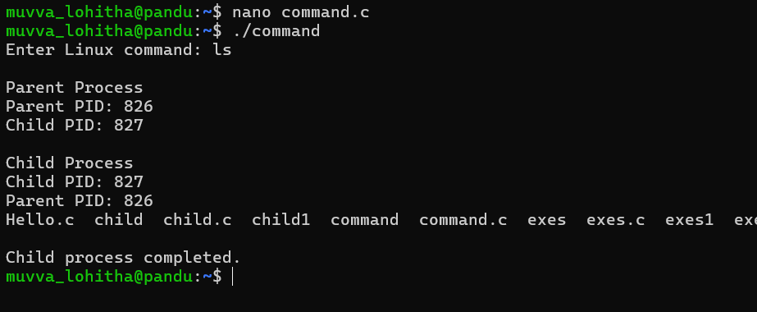
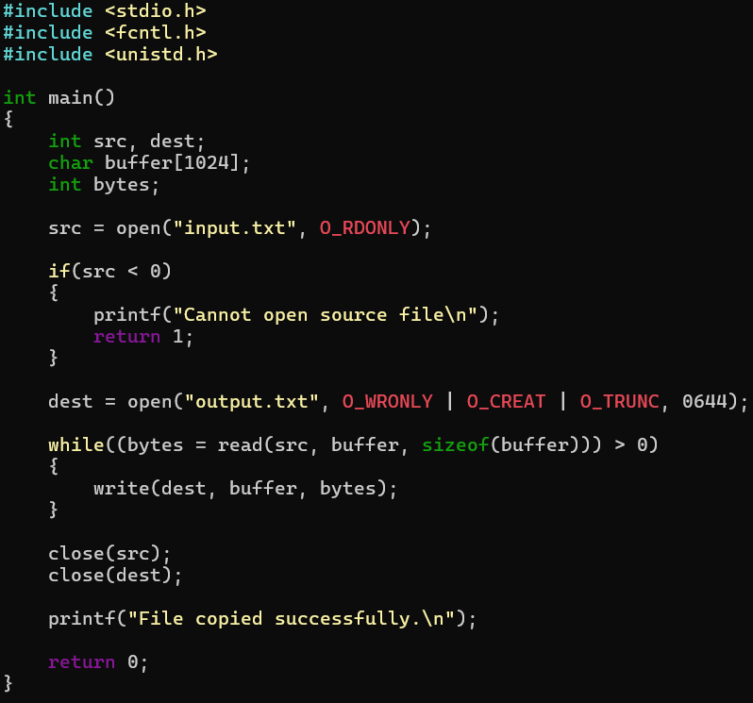
2. copying the contents from one file to another file

OUTPUT:
